Data Handling and Visualization (DSA06)
Name: Prasanna M Reg. No: 1925260244
Set 24: Product Inventory Management
Question 1. In R, create a bar chart to visualize the quantity of each product in the inventory. Label the axes and title the chart.
Program (R):
library(ggplot2)
inv <- data.frame(Product_ID = 1:5, Product_Name = paste("Product", LETTERS[1:5]),
Quantity = c(250,175,300,200,220))
ggplot(inv, aes(x = Product_Name, y = Quantity)) +
geom_col(fill = "steelblue", colour = "black", width = 0.6) +
geom_text(aes(label = Quantity), vjust = -0.3) +
labs(title = "Quantity Available by Product", x = "Product", y = "Quantity Available") +
theme_minimal()
Output:
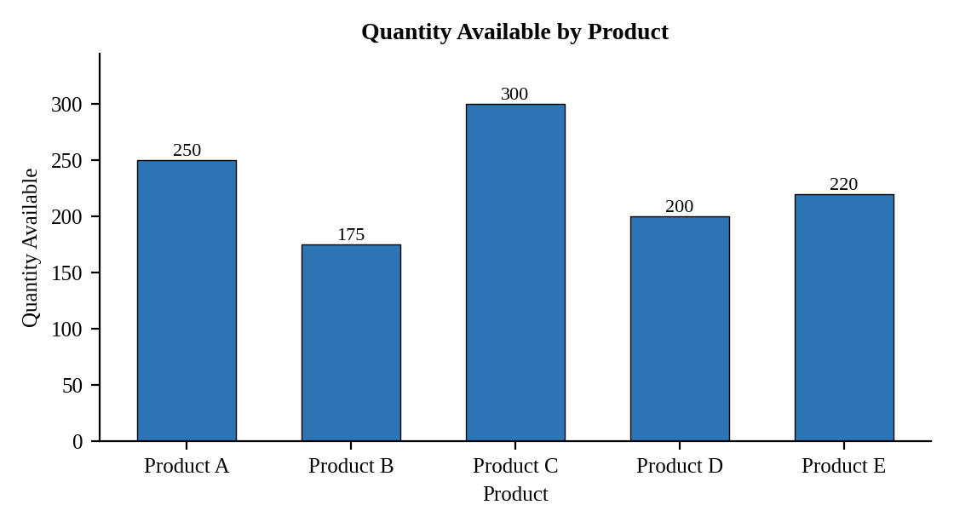
Interpretation:
Product C has the highest stock (300 units) and Product B the lowest (175 units). The total inventory is 1145 units, an average of 229 units per product.

Question 2. In R, generate a stacked bar chart to show the quantity of each product within different product categories.
Assumed data: No category data is given, so each product is split into two sample categories (Electronics and Accessories) that add up to its total quantity.
Program (R):
inv_cat <- data.frame(
Product = rep(paste("Product", LETTERS[1:5]), each = 2),
Category = rep(c("Electronics","Accessories"), times = 5),
Quantity = c(150,100, 75,100, 200,100, 120,80, 140,80))
ggplot(inv_cat, aes(x = Product, y = Quantity, fill = Category)) +
geom_col(position = "stack", colour = "black") +
geom_text(aes(label = Quantity), position = position_stack(vjust = 0.5)) +
labs(title = "Quantity by Product and Category", x = "Product", y = "Quantity Available") +
theme_minimal()
Output:
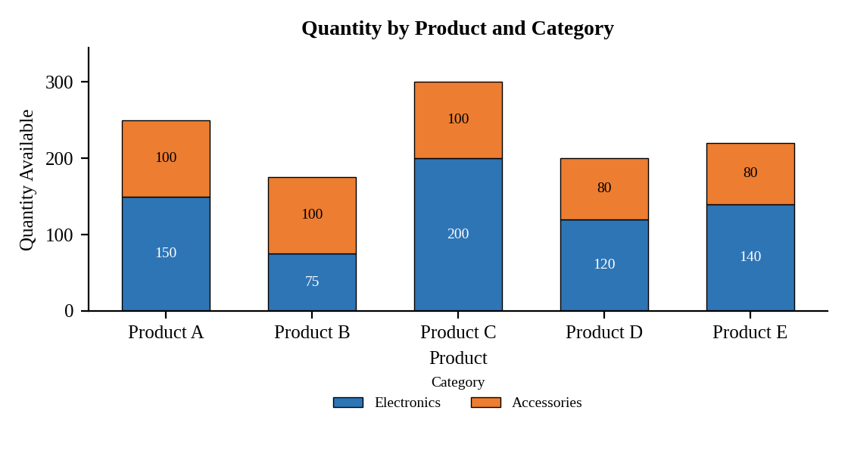
Interpretation:
Electronics account for 685 of the 1145 units (about 60%) and Accessories for 460 units (about 40%). Product B is the only product with more Accessories than Electronics.

Question 3. In Tableau, build a dashboard combining the bar chart and stacked bar chart for interactive exploration of inventory data.
Procedure (Tableau):
1. Open Tableau, click Connect, choose Text file / Microsoft Excel, select "Product_Inventory.csv" and open Sheet 1.
2. Add a Category field to the data source (Electronics / Accessories) with the quantity split for each product.
3. Sheet 1 (Bar): Columns = Product Name; Rows = SUM(Quantity Available); add labels.
4. Sheet 2 (Stacked bar): Columns = Product Name; Rows = SUM(Quantity Available); Color = Category; add labels.
5. Click New Dashboard, name it "Inventory Dashboard", set Size to Automatic and drag the sheets onto the canvas.
6. Select each chart and click the "Use as Filter" icon so that clicking a mark filters the other sheets; keep tooltips enabled.
7. Add a title to every sheet, adjust labels and colours, and save the workbook (File > Save As, .twbx).

Output:
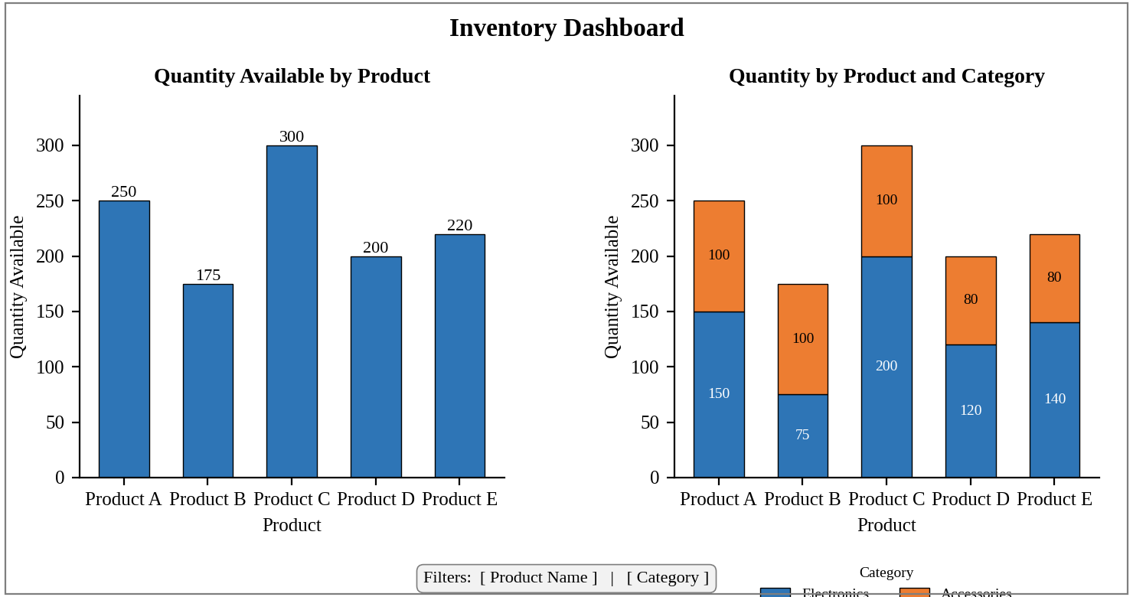
Dashboard layout (preview of the Tableau output).
Interpretation:
Clicking a product bar highlights its category split in the stacked bar, and clicking a category colour highlights its share in every product. The dashboard shows which products hold the most stock and which category dominates.

Question 4. In R, create a scatter plot to explore the relationship between product price and quantity available. Explain any insights.
Assumed data: Prices of Products A, B and C (20, 15 and 18 dollars) come from the inventory dataset in Set 18; sample prices of 22 and 17 dollars are assumed for Products D and E.
Program (R):
inv$Price <- c(20, 15, 18, 22, 17)
ggplot(inv, aes(x = Price, y = Quantity)) +
geom_point(size = 3, colour = "steelblue") +
geom_smooth(method = "lm", se = FALSE, colour = "red", linetype = "dashed") +
geom_text(aes(label = Product_Name), vjust = -1, size = 3) +
labs(title = "Price vs Quantity Available", x = "Price ($)", y = "Quantity Available") +
theme_minimal()
cor(inv$Price, inv$Quantity)
Output:
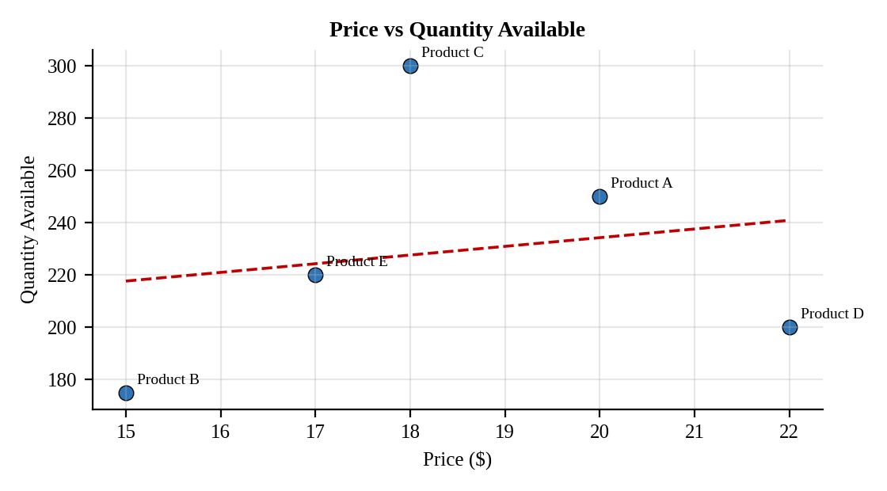
Interpretation:
The correlation is r = 0.19, a weak positive relationship, so price does not explain how much stock is held. The highest-priced product (D, 22 dollars) holds a mid-level stock of 200 units, while the cheapest (B, 15 dollars) has the lowest stock. Other factors such as demand should guide ordering.

